Problem 1 – Ship Damage
Inside the sea (a standard Cartesian /rectangular/ coordinate system) we are given a ship S (a rectangle whose sides are parallel to the coordinate axes), a horizontal line H (the horizon) and three catapults, given as coordinates C₁, C₂ and C₃ that will be used to fire the ship. When the attack starts, each catapult hits a projectile exactly into the positions that are symmetrical to C₁, C₂ and C₃ with respect to the horizon H. When a projectile hits some of the corners of the ship, it causes a damage of 25%, when it hits some of the sides of the ship, the damage caused is 50% and when it hits the internal body of the ship, the damage is 100%. When the projectile hit outside of the ship, there is no damage. The total damage is sum of the separate damages and can exceed 100%.
At the figure below a sea, a ship S, a line H, three points C₁, C₂ and C₃ and their hit positions are shown:
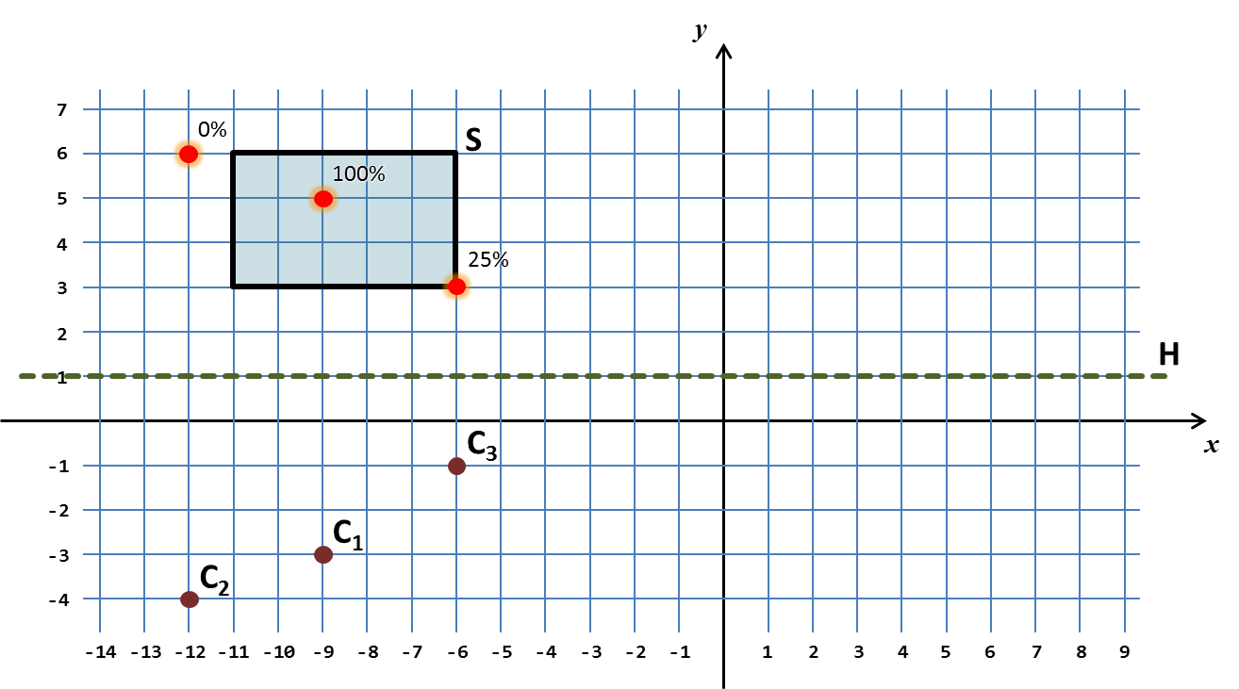
Your task is to write a program that calculates the total damage caused after the attack over the ship.

Input
The input data should be read from the console.
There will be exactly 11 lines holding the integer numbers S_{X1}, S_{Y1}, S_{X2}, S_{Y2}, H, C_{X1}, C_{Y1}, C_{X2}, C_{Y2}, C_{X3}, and C_{Y3}. The ship S is given by any two of its opposite corners and is non-empty (has positive width and height). The line H is given by its vertical offset. The points C₁, C₂ and C₃ are given as couples of coordinates and cannot overap each other.
The input data will always be valid and in the format described. There is no need to check it explicitly.

Output
The output data should be printed on the console.
The output should consist of a single line holding the total damage given as percentage.

Constraints
- The numbers S_{X1}, S_{Y1}, S_{X2}, S_{Y2}, H, C_{X1}, C_{Y1}, C_{X2}, C_{Y2}, C_{X3}, and C_{Y3} are all integers between -100 000 and 100 000, inclusive.
- Allowed work time for your program: 0.1 seconds.
- Allowed memory: 16 MB.

Examples
Input | Output |  | Input | Output
-11  6  -6  3  1  -9  -3  -12  -4  -6  -1 | 125% |  | -6  6  -11  3  1  -9  -4  -11  -1  2  2 | 75%

